PHASE 2 – GUIDEWIRE
ANALYSING THE DATASET AND DROPPED IRRELEVANT COLUMNS
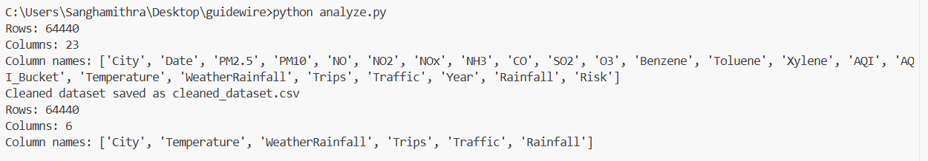

NEW COLUMN FOR OUTPUT HAS BEEN LABELLED:

DISRUPTION COLUMN DISTRIBUTION:
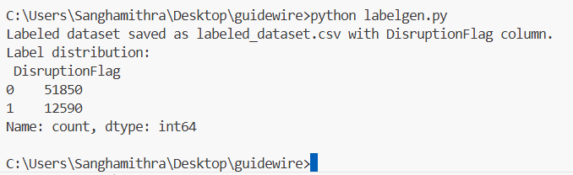

SPLITTED AND TRAINED THE MODEL:
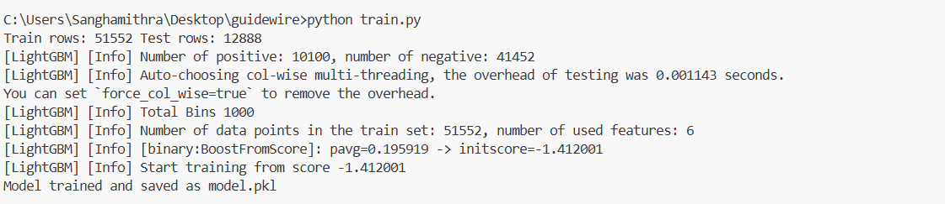
TESTING USING TEST DATASET:
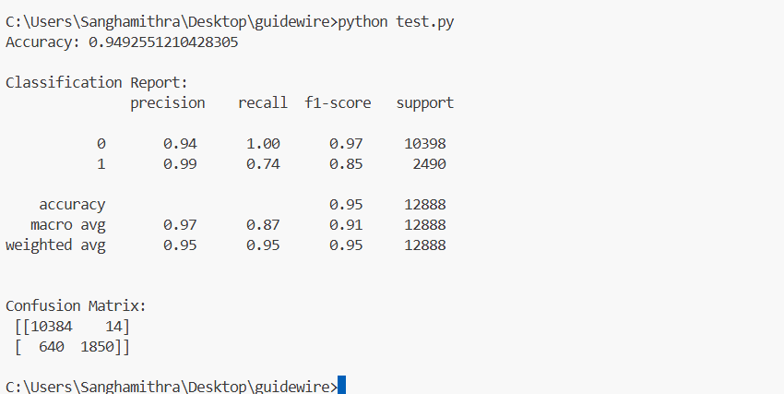

TESTING USING REAL TIME API DATA:
